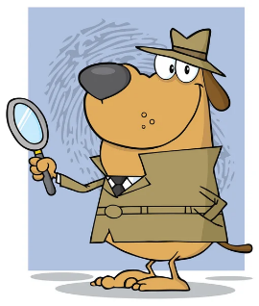
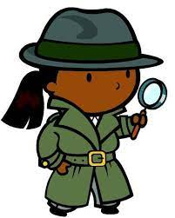
Identifying Important Points In An Article

Who is the article about?

What happened?

When did it happen?

Where did it happen?

How did the event happen?

Why did the event happen?

